**Hands on Exercise 6 - Criteria Query**

**CODE:**

**Product Class: -**

package com.cognizant.ex3handson6;  
import jakarta.persistence.*;  
  
@Entity  
public class Product {  
  
 @Id  
 @GeneratedValue(strategy = GenerationType.*IDENTITY*)  
 private int id;  
  
 private String name;  
 private int ramSize;  
 private String cpu;  
 private String operatingSystem;  
  
  
 public int getId() {  
 return id;  
 }  
  
 public void setId(int id) {  
 this.id = id;  
 }  
  
 public String getName() {  
 return name;  
 }  
  
 public void setName(String name) {  
 this.name = name;  
 }  
  
 public int getRamSize() {  
 return ramSize;  
 }  
  
 public void setRamSize(int ramSize) {  
 this.ramSize = ramSize;  
 }  
  
 public String getCpu() {  
 return cpu;  
 }  
  
 public void setCpu(String cpu) {  
 this.cpu = cpu;  
 }  
  
 public String getOperatingSystem() {  
 return operatingSystem;  
 }  
  
 public void setOperatingSystem(String operatingSystem) {  
 this.operatingSystem = operatingSystem;  
 }  
  
 @Override  
 public String toString() {  
 return "Product{" +  
 "id=" + id +  
 ", name='" + name + '\'' +  
 ", ramSize=" + ramSize +  
 ", cpu='" + cpu + '\'' +  
 ", operatingSystem='" + operatingSystem + '\'' +  
 '}';  
 }  
}

**ProductRepository Interface: -**

package com.cognizant.ex3handson6;  
import org.springframework.data.jpa.repository.JpaRepository;  
  
public interface ProductRepository extends JpaRepository<Product, Integer> {  
}

**ProductService Class: -**

package com.cognizant.ex3handson6;  
import jakarta.persistence.EntityManager;  
import jakarta.persistence.PersistenceContext;  
import jakarta.persistence.criteria.*;  
import org.springframework.stereotype.Service;  
  
import java.util.ArrayList;  
import java.util.List;  
  
@Service  
public class ProductService {  
  
 @PersistenceContext  
 private EntityManager entityManager;  
  
 public List<Product> searchProducts(String keyword, Integer minRam, String cpu, String os) {  
 CriteriaBuilder cb = entityManager.getCriteriaBuilder();  
 CriteriaQuery<Product> query = cb.createQuery(Product.class);  
 Root<Product> product = query.from(Product.class);  
  
 List<Predicate> predicates = new ArrayList<>();  
  
 if (keyword != null && !keyword.isEmpty()) {  
 predicates.add(cb.like(product.get("name"), "%" + keyword + "%"));  
 }  
  
 if (minRam != null) {  
 predicates.add(cb.greaterThanOrEqualTo(product.get("ramSize"), minRam));  
 }  
  
 if (cpu != null && !cpu.isEmpty()) {  
 predicates.add(cb.equal(product.get("cpu"), cpu));  
 }  
  
 if (os != null && !os.isEmpty()) {  
 predicates.add(cb.equal(product.get("operatingSystem"), os));  
 }  
  
 query.where(cb.and(predicates.toArray(new Predicate[0])));  
 return entityManager.createQuery(query).getResultList();  
 }  
}

**Main Class: -**

package com.cognizant.ex3handson6;  
  
import org.springframework.boot.SpringApplication;  
import org.springframework.boot.autoconfigure.SpringBootApplication;  
import org.springframework.context.ApplicationContext;  
  
import java.util.List;  
  
@SpringBootApplication  
public class Ex3handson6Application {  
  
 public static void main(String[] args) {  
 ApplicationContext context=SpringApplication.*run*(Ex3handson6Application.class, args);  
 ProductService productService=(ProductService) context.getBean(ProductService.class);  
 *testSearchProducts*(productService);  
 }  
 public static void testSearchProducts(ProductService productService) {  
 String keyword = "Laptop";  
 Integer minRam = 8;  
 String cpu = "Intel";  
 String os = "Windows 11";  
  
 List<Product> result = productService.searchProducts(keyword, minRam, cpu, os);  
  
 System.*out*.println("Filtered Products:");  
 for (Product p : result) {  
 System.*out*.println(p);  
 }  
 }  
}

**OUTPUT:**

Product table in database:

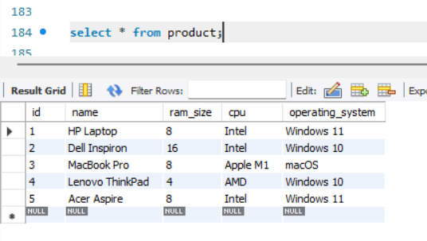

Now output of the code:

